**Assignment Day 7**

1. Rank employees by their total sales

(Total sales = Total no of orders handled, JOIN employees and orders table)

SELECT

e.employee_id,

e.first_name || ' ' || e.last_name AS employee_name,

COUNT(o.order_id) AS total_sales,

RANK() OVER (ORDER BY COUNT(o.order_id) DESC) AS sales_rank

FROM employees e

LEFT JOIN orders o ON e.employee_id = o.employee_id

GROUP BY e.employee_id, e.first_name, e.last_name

order by sales_rank ASC

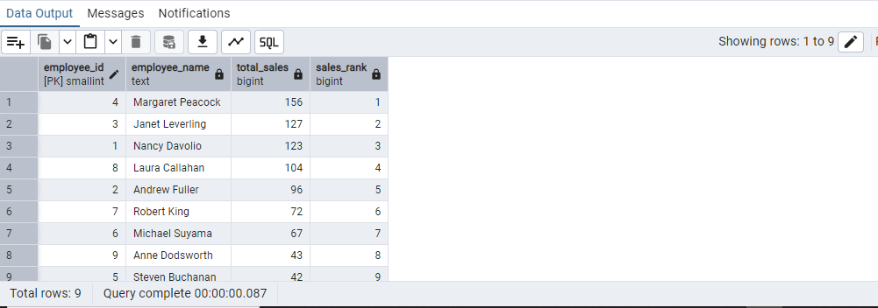

2. Compare current order's freight with previous and next order for each customer.

(Display order_id, customer_id, order_date, freight,

Use lead(freight) and lag(freight).

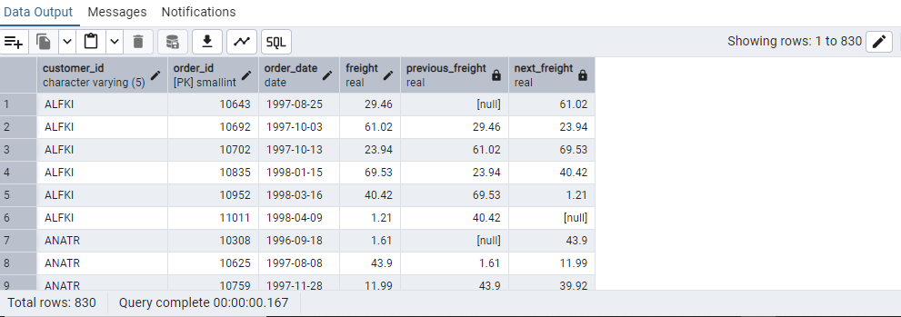

3. Show products and their price categories, product count in each category, avg price:

(HINT:· Create a CTE which should have price_category definition:

WHEN unit_price < 20 THEN 'Low Price'

WHEN unit_price < 50 THEN 'Medium Price'

ELSE 'High Price'

· In the main query display: price_category, product_count in each price_category, ROUND(AVG(unit_price)::numeric, 2) as avg_price)

WITH price_category AS (

SELECT

product_id,

product_name,

unit_price,

CASE

WHEN unit_price < 20 THEN 'Low Price'

WHEN unit_price < 50 THEN 'Medium Price'

ELSE 'High Price'

END AS unit_price_categories

FROM products

)

SELECT

unit_price_categories,

COUNT(product_id) AS product_count,

ROUND(AVG(unit_price)::numeric, 2) AS avg_price

FROM price_category

GROUP BY unit_price_categories

ORDER BY avg_price;

